Site Survey Questionnaire:
Please fill out form and return to AST Technical Team for estimating assistance: customerservice@appliedsystemtech.com
Any unknowns? We will make assumptions based on our experience and detail all assumptions when we return your completed estimate.
- What is your compressor(s) Horsepower or CFM output?
Compressor 1:
Compressor 2:
Compressor 3:

- Does the compressor room have other equipment to be piped? (Dryer, Filter(s), Tank etc.?) (Choose one X)

Yes: (Answer question 3) No: (Skip to question 4)

- List all equipment known connection sizes:
Compressor 1: Compressor 2: Compressor 3:
Dryer 1: Dryer 2:
Filter1: Filter 2: Filter 3: Filter 4:
Tank 1: Tank 2:
Other:
- If bypasses are required, how many? (Choose one X)
0: 1: 2:

- Do you plan a loop, or linear header? (Choose one X)
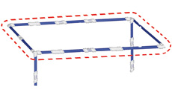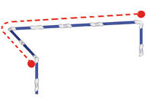
Loop: Linear:

- What is the estimated header piping system length or building dimensions, if header is length/width of building?
Length: Width:

Distance from compressor to header (If applicable)

- Header mounting (Choose one X)
Hanging from ceiling: Wall mounted:

- What is the ceiling height?

- What are the ceiling/walls made of? (Choose one X)
Steel beams: Sheet Metal: Drywall: Cement:

Wood: Other:

- How many drops to workstations or machines?

- What will the drops attach to for support?
Walls: Beams: Other:
- What is the average drop length? Try to pick an average drop length for estimating purposes.

- How are drops to be terminated? (Choose one X)

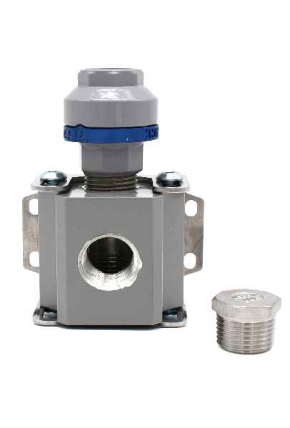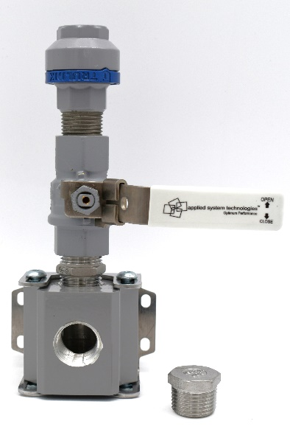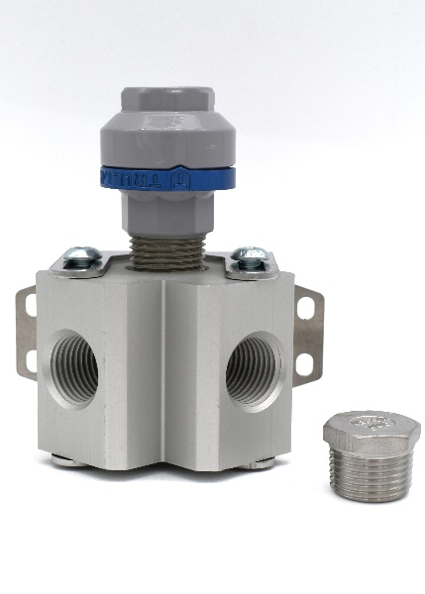
1-Port Outlet: 1-Port Outlet w/ Valve: 2-Port Outlet:
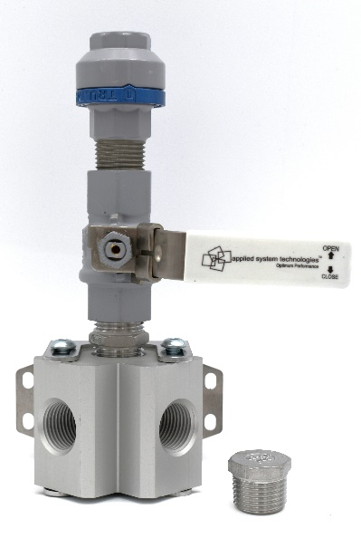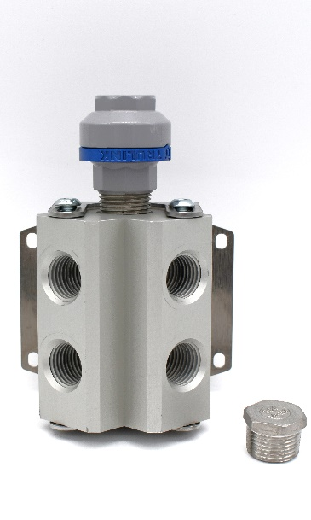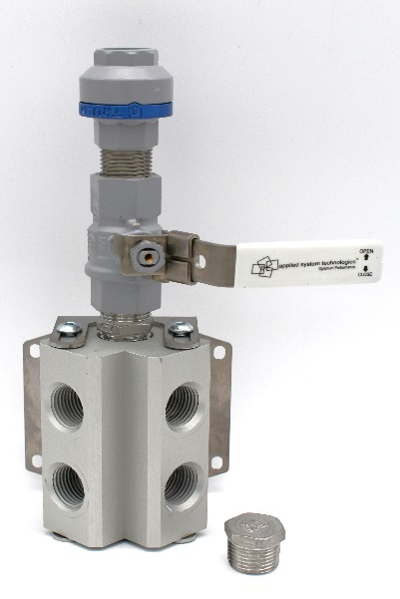
2-Port Outlet w/valve: 4-Port Outlet: 4-Port Outlet w/ valve:

- Drop accessories? (choose one or more X)
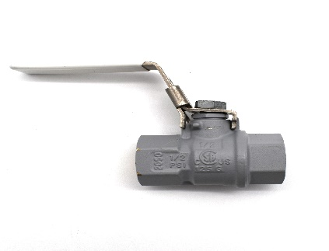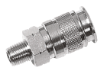
Valve: Quick connect:
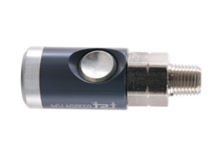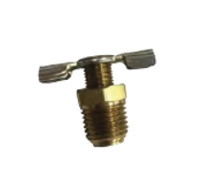
Safety quick connect: Drain:

- Are you connecting to existing piping? (choose one X)

Black Iron: Copper: Other:

- Do you need labor estimating assistance? (choose one X)
Yes: No:

